

**DEPARTMENT OF COMPUTER ENGINEERING & TECHNOLOGY**

**MIT Academy of Engineering**

**Dehu Phata, Alandi (D)**

**Pune - 412105, Maharashtra (India)**

**Report on Ardiuno based project**

Alcohol Sensor and Display Using OLED

**Submitted by:**

**Yushant Tyagi 203**

**Guided by:**

**Mr. Pramod Ganjewar**

**Arduino Uno:**

Arduino Uno is a microcontroller. It is a widely used open-source microcontroller board based on the [Microchip](https://en.wikipedia.org/wiki/Microchip_Technology) [AT mega328P](https://en.wikipedia.org/wiki/ATmega328P) microcontroller and developed by [Arduino.cc](https://en.wikipedia.org/wiki/Arduino). The board is equipped with sets of digital and analog input/output (I/O) pins that may be interfaced to various expansion boards (shields) and other circuits.

The components of Arduino studied were as under:

* Analog Reference pin
* Digital Ground
* Digital Pins 2-13
* Digital Pins 0-1/Serial In/Out
* Reset Button
* In-circuit Serial Programmer
* Analog In Pins 0-5
* Power and Ground Pins
* External Power Supply In (9-12VDC)
* Toggles External Power and USB Power
* USB (used for uploading sketches to the board and for serial communication between the board and the computer; can be used to power the board).

### **Power (USB / Barrel Jack)**

Every Arduino board needs a way to be connected to a power source. The Arduino UNO can be powered from a USB cable coming from your computer or a wall power supply that is terminated in a barrel jack.

### **Pins (5V, 3.3V, GND, Analog, Digital, PWM, AREF)**

The pins on your Arduino are the places where you connect wires to construct a circuit (probably in conjunction with a breadboard and some wire.

### **Reset Button**

Just like the original Nintendo, the Arduino has a reset button **(10)**. Pushing it will temporarily connect the reset pin to ground and restart any code that is loaded on the Arduino.

### **Power LED Indicator**

Just beneath and to the right of the word “UNO” on your circuit board, there’s a tiny LED next to the word ‘ON’ **(11)**. This LED should light up whenever you plug your Arduino into a power source.

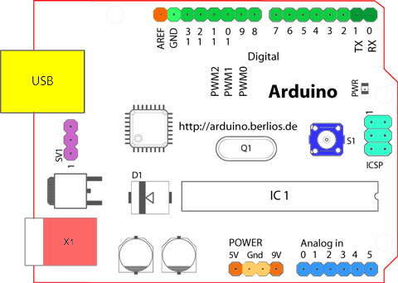

Problem Statement

There exist many people who break the traffic rules as drinking and driving. Even policemen can’t be that efficient that they could be 100 % correct. So here we have designed an Alcohol detector which could be placed in car and till the time it does not specifies the level is stable the car won’t start.

List of Sensor with Description

# MQ135 Alcohol Sensor

# The MQ series of gas sensors utilizes a small heater inside with an electro chemical sensor these sensors are sensitive to a range of gasses are used at room temperature. MQ135 alcohol sensor is a Sno2 with a lower conductivity of clean air.

The MQ135 gas sensor has high sensitivity in ammonia, sulfide, bonze steam, smoke and in other harm full gas. It is low cost and suitable for different applications. There are different types of alcohol sensors like MQ-2, MQ-3, MQ-4, MQ-5, MQ-6, etc.

Snaps of project:

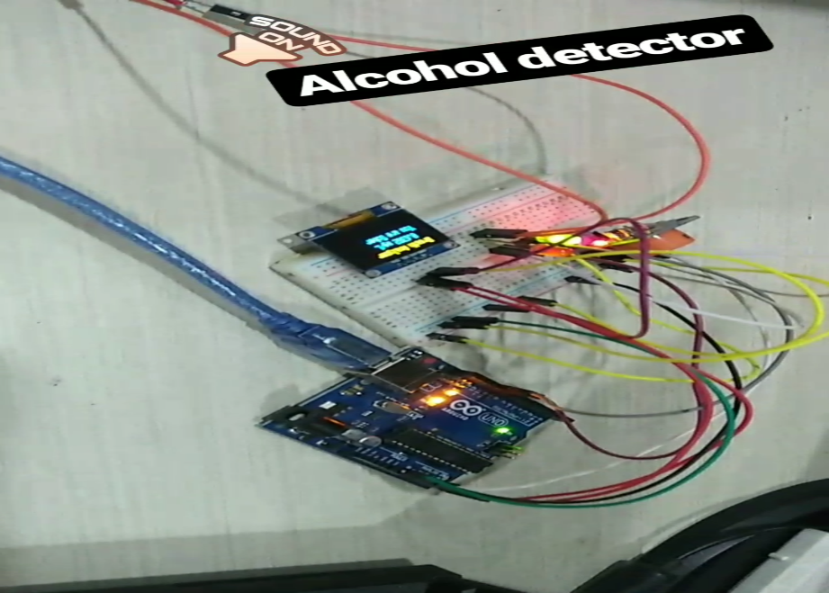

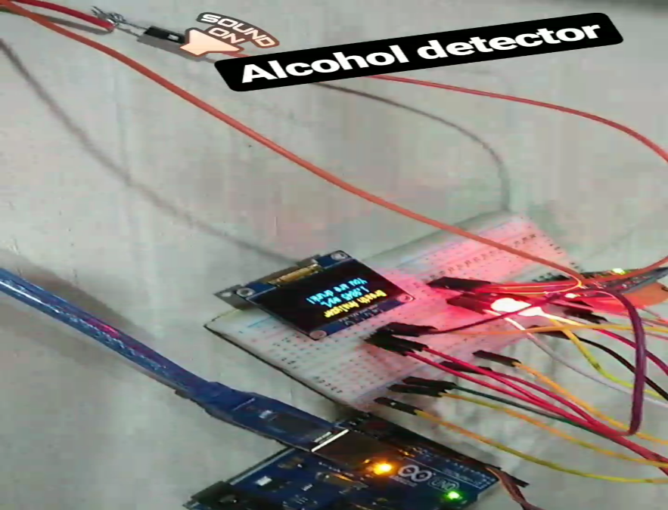

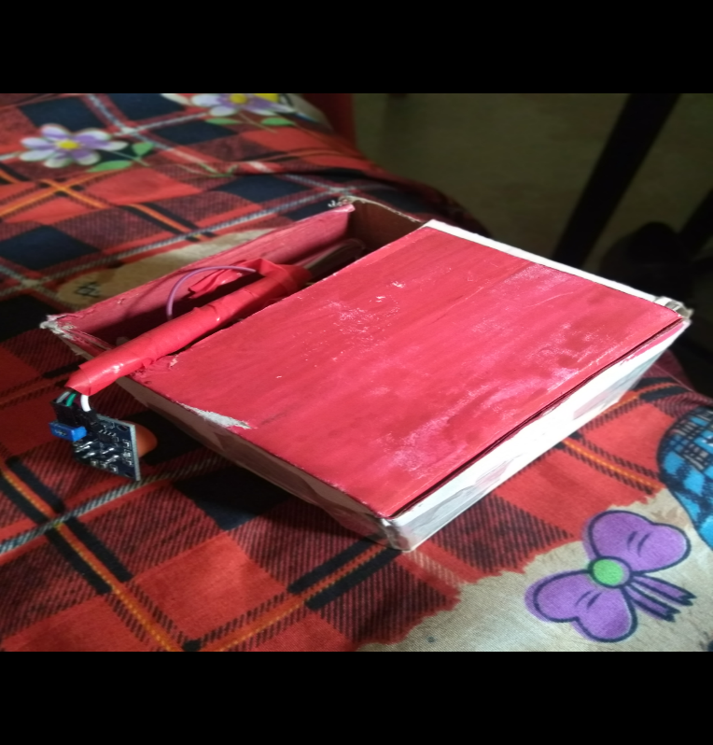

Program written on Arduino:

#include <SPI.h>

#include <Wire.h>

#include <Adafruit_GFX.h>

#include <Adafruit_SSD1306.h>

int i=0;

#define OLED_RESET 4

int TIME_UNTIL_WARMUP =10;

unsigned long time;

int analogPin = 0;

double val = 0;

Adafruit_SSD1306 display(OLED_RESET);

void setup()   {

Serial.begin(9600);

 display.begin(SSD1306_SWITCHCAPVCC, 0x3C);

 display.clearDisplay();

 pinMode(13,OUTPUT);

 pinMode(12,OUTPUT);

}

void loop() {

  //digitalWrite(13,HIGH);

  //digitalWrite(12,HIGH);

  delay(100);

  val = readAlcohol();

  printTitle();

  printWarming(i);

  time = millis()/1000;

  if(time<=TIME_UNTIL_WARMUP)

  {

    time = map(time, 0, TIME_UNTIL_WARMUP, 0, 100);

    display.drawRect(10, 50, 110, 10, WHITE); //Empty Bar

    display.fillRect(10, 50, time,10,WHITE);

  }else

  {

     printTitle();

     printAlcohol(val);

     printAlcoholLevel(val);

  }

  display.display();

//printled(val);

}

void printTitle()

{

  display.clearDisplay();

  display.setTextSize(1);

  display.setTextColor(WHITE);

  display.setCursor(10,0);

  display.println("Breath Analyzer");

}

void printWarming(int &i)

{

  if(i>125){

    i=0;

  }

  display.setTextSize(2);

  display.setTextColor(WHITE);

  display.setCursor(i,17);

  display.println("Warming up");i+=8;

}

void printAlcohol(int value)

{

  display.setTextSize(1.5);

  display.setTextColor(WHITE);

  display.setCursor(20,10);

  display.print(val,4);display.println(" mg/L");

}

void printAlcoholLevel(int value)

{

  digitalWrite(13,HIGH);

  display.setTextSize(1);

  display.setTextColor(WHITE);

  display.setCursor(10,20);

  if(value<0.6600)

  {

      display.println("You are Sober");

    Serial.println("you are sober");

  }

  if (value>=0.6600 && value<0.7900)

  {

      display.println("Had a Beer.");

      Serial.println("Had a Beer.");

  }

  if (value>=0.7900 && value<0.8500)

  {

      display.println("Two or more beers.");

  }

  if (value>=0.8500 && value <0.9200)

  {

      display.println("I smell Oyzo!");

  }

  if(value>=0.9200)

  {

     display.println("You are drunk!");

    digitalWrite(13,LOW);

    //digitalWrite(12,HIGH);

     for(int i=0;i<3;i++){

     digitalWrite(12,HIGH);

     delay(70);digitalWrite(12,LOW);delay(70);

     }

  }

 }

 double readAlcohol()

 {

 double adcValue=0;

 for(int i=0;i<30;i++)

  {

    adcValue+= analogRead(analogPin);

    delay(20);

  }

    double v= (adcValue/30) * (5.0/1024.0);

    double mgL= (0.37 * v)/1.2;

  display.clearDisplay();

  return mgL;

 }

/*

void printled(double value){

   if(value<0.6600)

  {

    for(int i=0;i<100;i++){

      digitalWrite(13,HIGH);delay(2000);digitalWrite(13,LOW);delay(1000);

    }

  }

  if (value>=0.6600 && value<0.7900)

  {

      for(int i=0;i<100;i++){

      digitalWrite(13,HIGH);delay(800);digitalWrite(13,LOW);delay(800);

    }

  }

  if (value>=0.7900 && value<0.8500)

  {

       for(int i=0;i<100;i++){

      digitalWrite(13,HIGH);delay(600);digitalWrite(13,LOW);delay(600);

    }

  }

  if (value>=8500 && value <0.9200)

  {

       for(int i=0;i<100;i++){

      digitalWrite(13,HIGH);delay(400);digitalWrite(13,LOW);delay(400);

    }

  }

  if(value>=0.9200)

  {

    for(int i=0;i<100;i++){

      digitalWrite(13,HIGH);delay(400);digitalWrite(13,LOW);delay(400);

    }

  }

}

Applications Of Your Project

The Presented Alcohol can be used in many places but it could be innovatively used in future as , if the alcohol content of the driver is greater then the specified content then the car wont start and when the level of the alcohol content will go below the specified content then the car will go on. This is a future based application of our alcohol sensor and these types of sensors are being used by Policemen.

Conclusion

The project Taken by us i.e. Alcohol Detector is working efficiently and showing all the levels in proper way …………………………………………….

References:

* <https://www.youtube.com/watch?v=r3z5GIRbzCY>
* <https://circuitdigest.com/microcontroller-projects/arduino-motion-detector-using-pir-sensor>
* <https://www.wikipedia.org/>